# Related work

## Cato Model

The Cato updated model (without Clemens productivity adjustments) estimates an overall federal fiscal impact of $10,210 - $8,944 = $1,265 for 2018 (in 2023 USD).[1] Below is the federal fiscal impact for 2018 broken out by immigrant generation and education level.[2] This approach assigns the marginal cost of public goods to immigrants; while we treat them as fixed. We estimate government expenditures to be $6,425; higher for methodological reasons, and changes in the federal budget.

Broken out by education only, the Cato model reports lower tax revenues from immigrants than our model. The Cato model also reports lower tax collections. For the median H-1B income earner, we estimate taxes to be $42,418, and $47,872 for the mean income earner. This is due to the wide distribution of incomes in each educational attainment category.

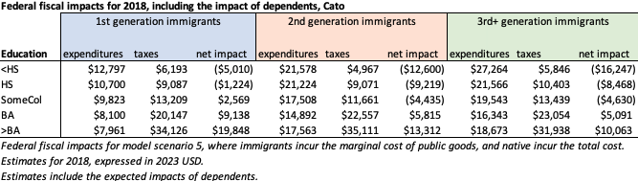

Breaking out tax revenues by education in the Cato model, we report higher income taxes, excise taxes, and payroll taxes when broken out by education. For income quintiles, including only the BA+ population, income and excise taxes are more comparable, though OASDI taxes are notably lower.

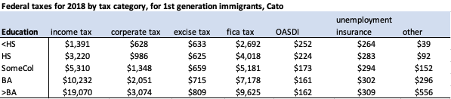

But when broken out by income quintile for the highly educated immigrant population only, tax revenues are far more comparable, apart from OASID tax revenues.

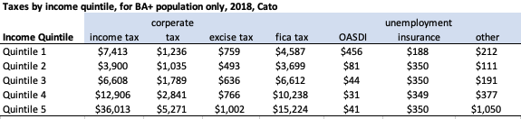

Breaking the Cato model out by income and education quintile, for a single immigrant worker, the Cato model reports $3,319 in government expenditures and $49,635 in tax revenues for the BA+ population in the highest wage/salary income quintile, and a net impact of $35,134. These are nearly equivalent to our median estimate.

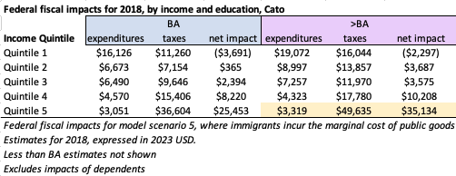

## 

## Work Authorization

Our methodology to estimate H-4 work authorization follows Bier 2020,[3] but focusing on initial work authorization approvals only to be directly comparable with the rates of spouses and children obtaining permanent residence in the United States.

XXXXX estimates that, of those eligible for a H-4 visa, 83% are working.

## Excise taxes

For the Manhattan Institute Daniel Di Martino estimates the following excise tax revenues by educational attainment and selected age group for immigrants. These estimates, particularly at the Bachelor’s degree and higher are significantly higher than ours. One reason for this is that these are estimated using a subset of the ACS immigrant population, rather than the full population, as our CES based approach provides.

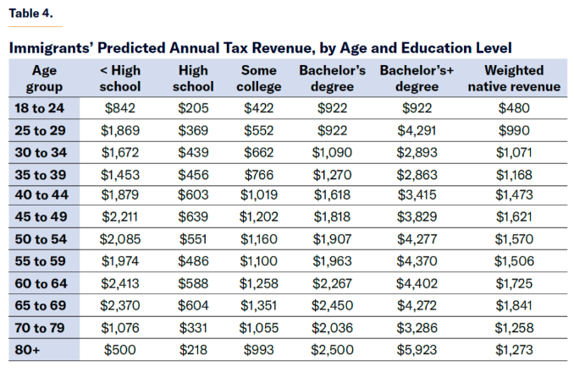

However, the National Academies of Science’s estimate, and the Cato model estimate, line up well with our approach. The following is a table of excise taxes applied to (immigrants??) broken out by the same education and age groups, using microdata I possess from the NAS and Cato models.

**NAS and Cato model, Excise taxes for 2018 (2023 USD), Including native-borns**

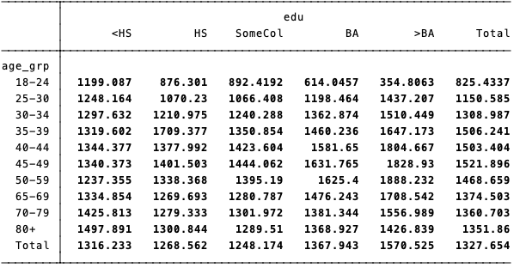

**NAS and Cato model, Excise taxes for 2018 (2023 USD), Immigrants only**

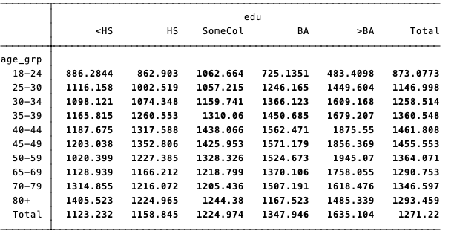

This matches up nicely with our method when applied to education and age groups, though we have higher estimates for the >BA age group, particularly for older populations, which may be due to an under-sampling of the >BA elderly population in the CES. The NAS/Cato/Manhattan estimates are based on CES regressions applied to the CPS, with CPS weights (implicitly assuming similar distributions in the CES and CPS).

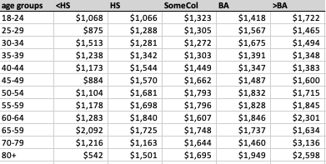

Here are the National Academies' and Cato’s estimates when applied to our education level X quintile groupings.

### Additional estimates

Estimates for excise tax rates by income quintile vary widely based on methodology. The CBO and the Tax Foundation follow similar methodologies using data from the IRS. Both are lower estimates than our model, as well as the NAS model, Cato, and Manhattan institute models.

**Tax Foundation[4]**

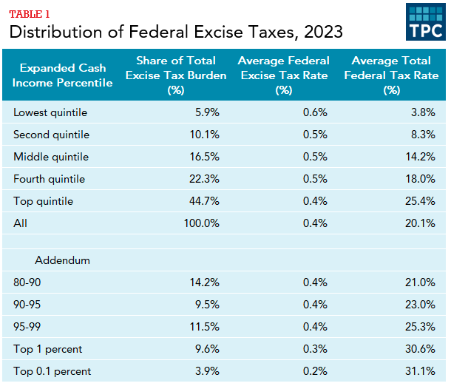

**CBO[5]**

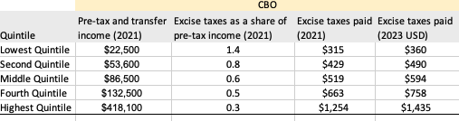

1. [Fiscal Impact of Immigration](https://www.cato.org/white-paper/fiscal-impact-immigration-united-states#fiscal-impacts-new-immigrant-detailed-results), Table 2 (Cato numbers are reported in 2012 USD). Using [CPI-U](https://www.bls.gov/cpi/data.htm), January monthly estimate.
2. 1st generation are those who migrated to the United States, 2nd generation are native born of foreign born parents, 3rd+ generation immigrants are born to U.S. born parents. Tables constructed from the Cato Model microdata.
3. <https://www.cato.org/blog/facts-about-h-4-visas-spouses-h-1b-workers#_edn46>
4. [Tax Policy Briefing Book](https://taxpolicycenter.org/briefing-book/who-bears-burden-federal-excise-taxes#:~:text=That%20is%2C%20the%20average%20federal,1%20percent%20(table%201))
5. [Distribution of Household Income in 2021](https://www.cbo.gov/publication/60341), data comes from the *additional data for researchers* file.